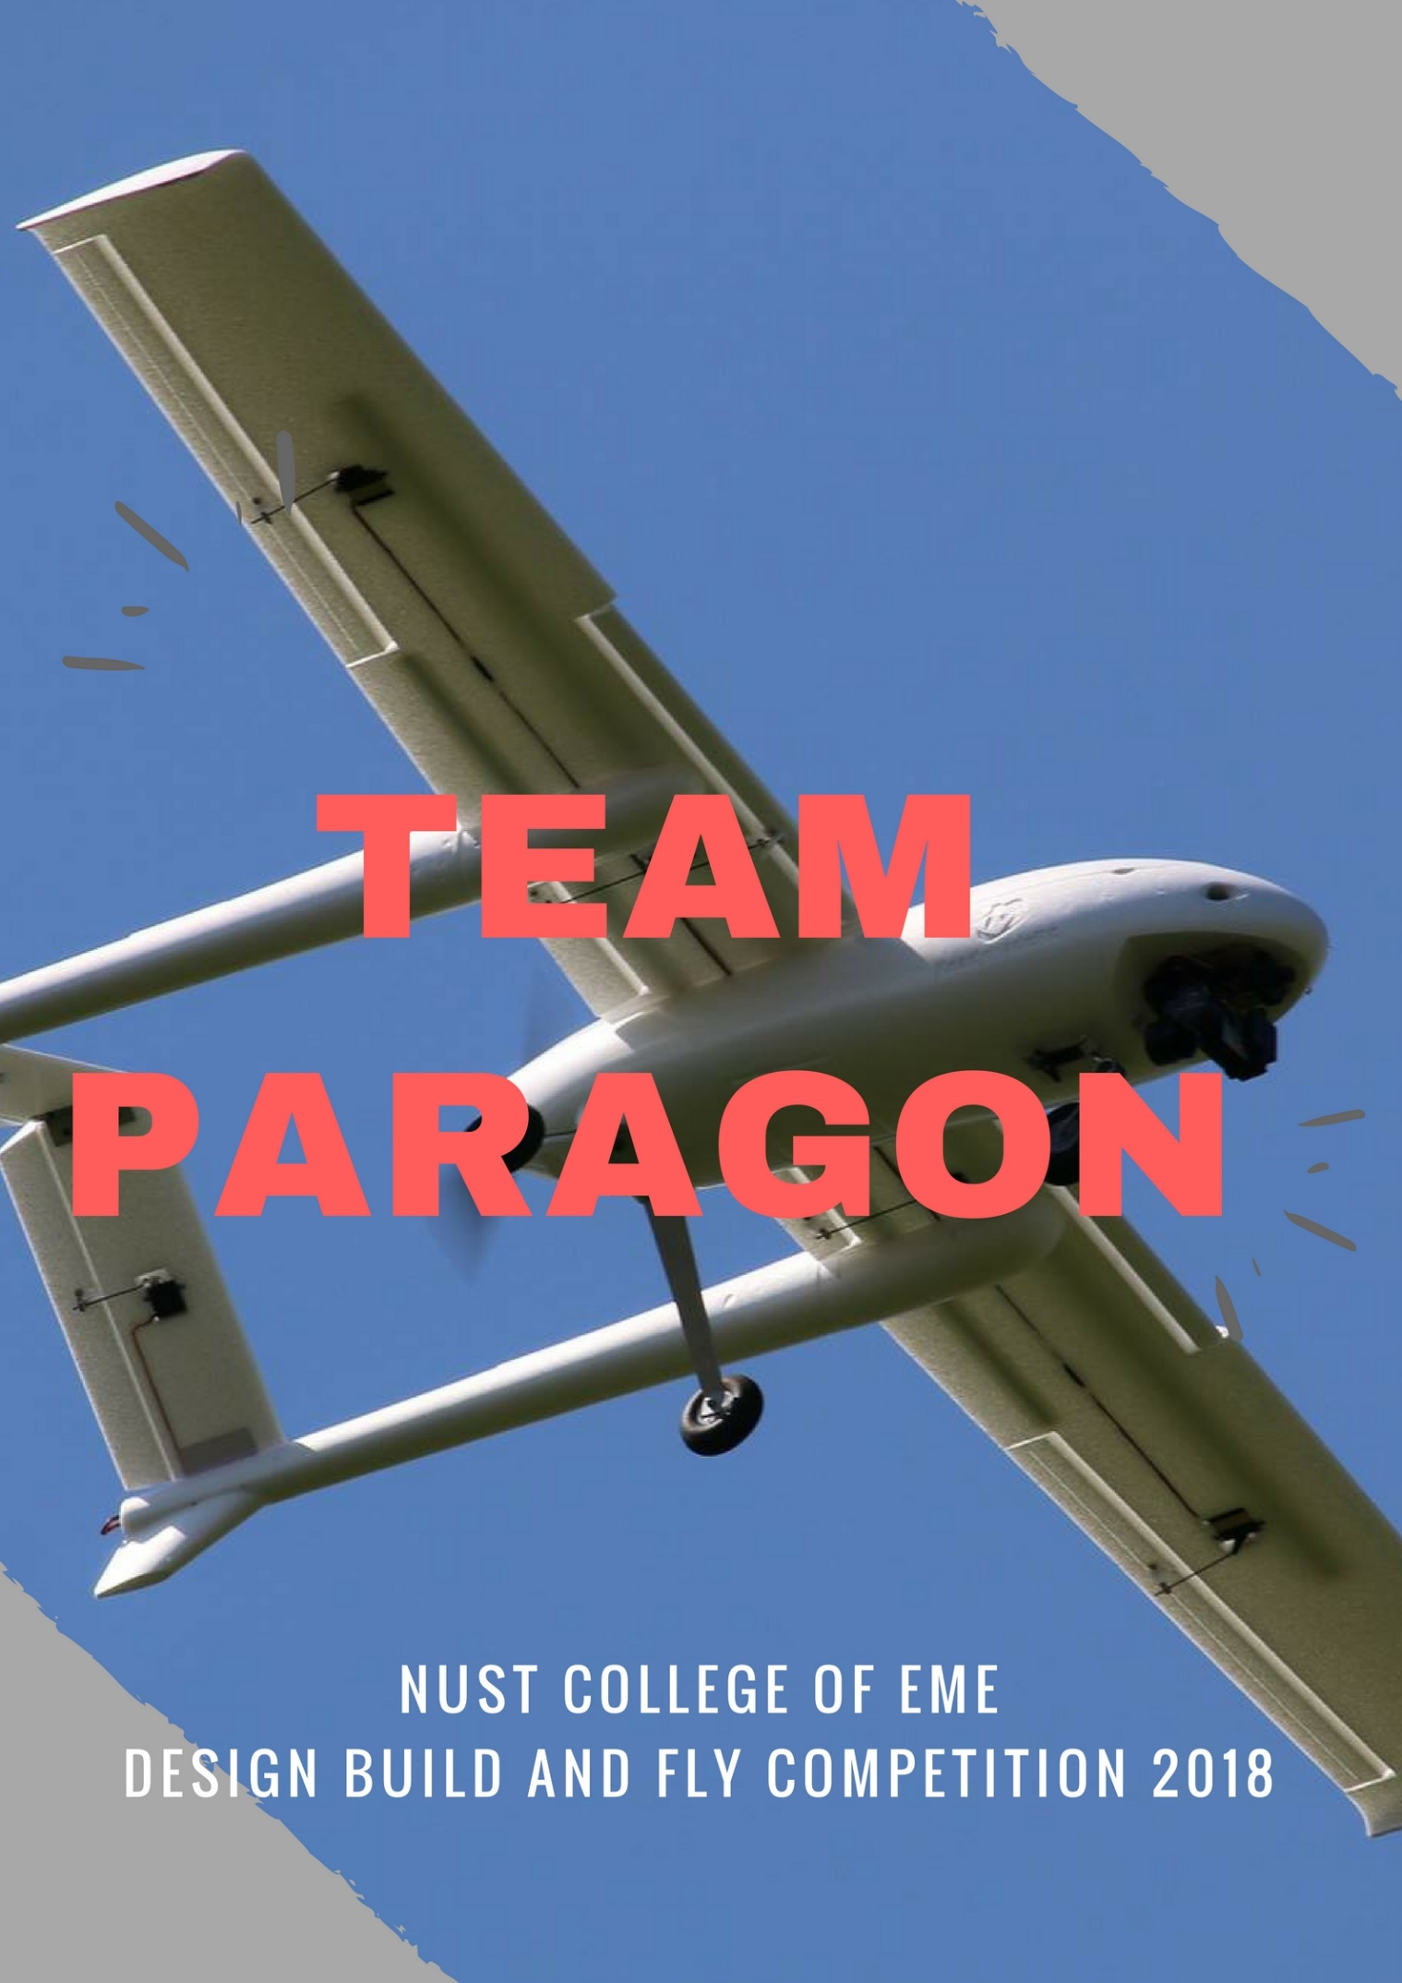



**IN REFERENCE TO THE REQUIREMENTS FOR DBFC-13**

**MUHAMMAD ARMGHAN**

**HASNAIN AZAM**

**USMAN SHOUKAT**

**MUHAMMAD HASSAN MOHIUDDIN**

**MUHAMMAD NOOR ULLAH**

**UNDER THE SUPERVISION OF:**

**DR. ZAFAR ABBAS BANGASH**

**DEPARTMENT OF MECHANICAL ENGINEERING**

**COLLEGE OF ELECTRICAL & MECHANICAL ENGINEERING (CEME) NATIONAL UNIVERSITY OF SCIENCE & TECHNOLOGY, ISLAMABAD**

**COPYRIGHT STATEMENT**

**Copyright in text of this report rests with the student authors. Copies either in full, or of extracts, may be made only in accordance with instructions given by the author. This page must form part of any such copies made. Further copies (by any process) of copies made in accordance with such instructions may not be made without prior permission of the student author.**

Table of Contents

1.0 Executive Summary 6

Management Summary 8

2.1 Team Structure: 8

2.2 Milestone Chart: 9

3.0 Conceptual Design 0

3.1 Mission Requirement and Scoring Analysis: 0

3.1.1 General Mission Requirement. 0

3.2 Specific Mission Requirements: 1

3.2.1 Mission 1 (Without Payload): 1

3.2.2 Mission 2 (With Payload): 1

3.2.3 Mission 3 (Endurance Limit Check): 1

3.3 Design and Configurations: 2

3.3.1 Wing Configurations with respect to Position 2

3.3.2 Tail Configuration: 3

3.3.3 Payload Configuration: 4

3.3.4 Fuselage Configuration: 4

3.3.5 Thrust: 4

3.3.6 Payload: 4

3.3.7 Drag: 4

3.3.8 Landing Gear: 4

3.4 Final Conceptual Design: 5

4.0 Preliminary Design 6

4.1 Wing Design: 6

4.2 Design Trade Study 7

4.2.1 Stability 7

4.2.2 Static Stability 7

4.2.3 Lateral Stability 7

4.3 Airfoil Selection: 8

4.3.1 Lift Drag Analysis of Mh114: 10

5.0 Detail Design 14

5.1 Overall Dimensions of plane 14

5.2 Tail: 15

5.3 Controls and Servo Mechanism: 16

5.3 Drawing Package 16

6.0 Manufacturing Plan and Process 18

6.1 Material Selection: 18

6.1.1 Balsa Wood: 18

6.1.2 Carbon Fiber: 18

6.2 Final Selection: 19

6.2.1 Weight: 19

6.2.2 Manufacturing Ease: 19

6.2.3 Cost: 19

6.2.4 Strength: 19

6.3 Wing and Tail Design: 20

6.4 Fuselage: 20

6.5 Propulsion: 20

6.7 Cost and Money: 20

7.2 Surface analysis 21

7.4 Safety Checks Prior to Test Flight: 23

DESIGN REPORT

TEAM PARAGON

NUST EME PARAGON

# 1.0 Executive Summary

DBFC-13 presented missions this year to its participating teams are different and challenging from all previous competitions. In which most important ones are usage of pusher mechanism and low-battery limit of 2200mAh.

The flight score consists of three achieved goals. The first goal is flying without payload, second goal is flying with external payloads and the last is check of endurance limit of plane i.e. max time of flight with battery and external payload. A successful landing is mandatory to get score for the mission.

After the extraction of basic knowledge, all 5 members of the team works on different tasks according to their Interests. Different team members did different tasks according to their field of interest. We moved in planed manner like selection of airfoil having highest lift to drag and Lift Coefficient, enough strength to complete all the tasks with given payload and most importantly optimum design for low rated battery.

Aircraft’s wing and structure was designed to with pusher mechanism with ability to bear stresses while performing loops so we use NACA airfoil MH114 which gives excess lift according to given conditions. Wing span is of 50 inches with 10 inch of chord length. 50-inch span with small fuselage will give maximum lift while bearing enough stresses, also MH114 can be manufactured with great accuracy. Balsa wood is used as construction Material for the plane’s body while foam is added to interior surfaces to decrease weight. Balsa wood is light in weight, cheap and easily available. Fuselage is manufactured with varying thickness and reinforcements of critical areas. There are three missions of the flight. First one is flight without payload. It requires ability of plane to cruise in minimum amount of time as time is the key in this mission. For this we have made smaller fuselage with large wing span for minimum weight and maximum lift. Also single boom is used so that we have minimum weight. Plane has high wing configuration for greater stability and lift. Second mission is flight with external payload. It demands enough strength of plane as there is high chance of fracture while performing loop and it also requires ability to do it as quickly as possible. Third mission is Endurance ability of plane with given low rated battery. This requires a light weight plane with high lift to drag coefficient airfoil and smaller fuselage for minimum drag. For this we have designed small cross section fuselage. Ability of Lift of MH114 at Zero angle of attack also helps us in keeping our plane in air with minimum usage of battery.

# Management Summary

## 2.1 Team Structure:

Our team consists of 5 members as according to the guidelines. Work was equally distributed along all the members so that everyone should have opportunity to learn.

Primary Area of Work are:

1. Aerodynamics
2. Computer Aided Design
3. Structure Analysis
4. Propulsion

Team structure is defined as follow:

**NUST**

**Faculty Advisor**

**Dr. Zafar Bangash**

**Propulsion**

**Usman Shoukat**

**Noor Tiwana**

**Team Leader**

**M**

**Armghan**

**Structure**

**Analysis**

**Noor Tiwana**

**Armghan**

**Hasnain Azam**

**Aerodynamics**

**Usman Shoukat**

**Hassan Mohiuddin**

**Solidworks Design**

**Armghan**

**Hassan Mohiuddin**

**Hasnain azam**

## 2.2 Milestone Chart:

***Table 2.1 Milestone Chart***

# 3.0 Conceptual Design

The conceptual design phases are the most fundamental part of Design. It includes making your idea feasible according to the Competition requirements of the plane. So as a first step, we should know all the mission and General requirements for the Competition.

## 3.1 Mission Requirement and Scoring Analysis:

DBFC-13 comprises of 3 mission performances, design report submission and conduction of viva on the competition date.

Grading scheme will be as follow:

* Design report: 25 %
* De-Briefing and Viva Voce: 30 %
* Flying: 45%

## 3.1.1 General Mission Requirement.

* The aircraft should be designed in Pusher Configuration, like a Single or Twin Booms pusher or any other pusher configuration.
* The wingspan of the aircraft should not be more than 2.5 meters.
* The weight of the aircraft should not be more than 3 Kg (For all missions).
* Lithium Polymer (LiPo) battery is allowed. The battery should not have a rated capacity of more than 2200 mAh and the rated voltage should not be more than 12 V.
* The teams must use transmitters and receivers with telemetry capability (for example Turnigy TGY-i6). The receiver should relay the voltage of the battery during flight to the transmitter using an on-board voltage sensor.

## 3.2 Specific Mission Requirements:

These individual mission requirements will limit our design as plane is to be made by taking care of all individual requirements.

## 3.2.1 Mission 1 (Without Payload):

* Take-off within the prescribed area.
* Perform basic maneuvers: Circuit Pattern, Aileron Roll and Inside loop. All maneuvers should be completed within 4 minutes.
* Time starts when the throttle is advanced for the (first) take-off (or attempt)
* Mission performance will be normalized over all teams successfully completing this mission.
* A successful landing is mandatory to get score for the mission

## 3.2.2 Mission 2 (With Payload):

* Payload should be exactly 300 grams in weight. The teams can choose the dimensions and material of the payload to suit their design.
* The payload should be a separate entity. It must not be a structural or functional part of the aircraft.
* Take-off within the prescribed area with payload.
* Perform 2 complete circuit patterns and establish final approach for landing.
* The payload must be secured in place to ensure that it does not move around during flight.
* A successful landing is mandatory to get score for the mission.

## 3.2.3 Mission 3 (Endurance Limit Check):

* The goal of this mission is to stay airborne for as long as possible using the predefined battery capacity that is 2200 mAh with 12 V.
* This mission will be carried out with the payload.
* Take-off within the prescribed area carrying payload
* Perform loiter pattern above the flying field for as long the design permits.
* The battery voltage should be monitored reliably with an onboard voltage sensor. This is necessary for safe operation of the aircraft. It ensures that voltage does not drop below a safe limit.
* Once the battery voltage has dropped to 9.5 V, the pilot must land the plane immediately.
* A successful landing is mandatory to get score for the mission.

## 3.3 Design and Configurations:

## 3.3.1 Wing Configurations with respect to Position

There are many types of wing configuration:

1. [Low wing](https://en.wikipedia.org/wiki/Low_wing): mounted near or below the bottom of the fuselage.
2. [Mid wing](https://en.wikipedia.org/wiki/Mid_wing): mounted approximately halfway up the fuselage.
3. [Shoulder wing](https://en.wikipedia.org/wiki/Shoulder_wing): mounted on the upper part or "shoulder" of the fuselage, slightly below the top of the fuselage. A shoulder wing is sometimes considered a subtype of high wing.
4. [High wing](https://en.wikipedia.org/wiki/High_wing): mounted on the upper fuselage. When contrasted to the shoulder wing, applies to a wing mounted on a projection (such as the cabin roof) above the top of the main fuselage.

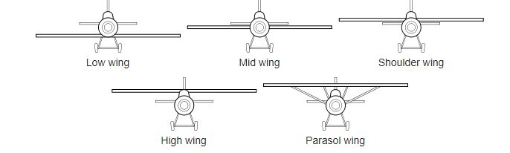

***Figure 3.1 Wing Configurations with respect to Position of wings.***

We also used flat wings configuration for our plane not dihedral because the dihedral wings provide stability to plane to return to normal position but in order to perform aerobatics this type of stability is not favored.

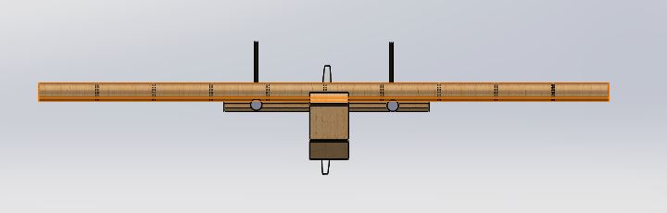

NOT DIHEDRAL

**Fig 3.2 Front View of Plane**

As required, taking care of 3rd mission requirement, we need wing configuration that is easy to manufacture and gives enough lift for Mission 2. High wing configuration is optimum choice as it is gives more lift and more stability. Mid and high wing although gives more maneuverability but causes some stability issues hence not feasible.

During Conceptual Design and analysis, mono plane configuration is considered more feasible as it is more simple as compared to Bi plane and other configurations. With small fuselage, Bi plane configuration increases weight which affects overall performance

Delta and canard configuration are not used due to their complexity in manufacturing and also causes case for problem.

## 3.3.2 Tail Configuration:

There are mainly three tail designs are used:

* Convectional
* V Tail
* Split Tail.
* Boom tail

Pusher Mechanism in our design needs two booms which will hold the tail hence it requires boom Tail configuration for better Controllability and Stability.

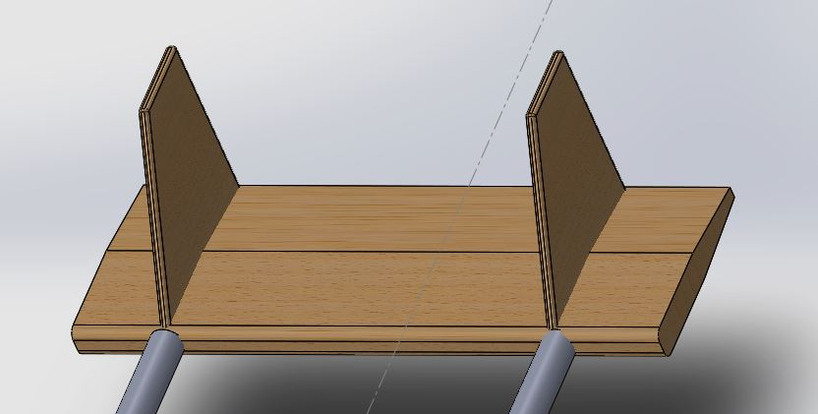

***Fig 3.3 Tail Design***

## 3.3.3 Payload Configuration:

Payload requirements this year are payload of 300 g of any geometry and material. While considering our mission requirements, a concentrated weight of 300 g is best choice as it can be fitted in fuselage with minimum stability issues. Concentrated payloads causes stability problem during cruising.

## 3.3.4 Fuselage Configuration:

Selection of Fuselage is very important as it is main hurdle between propeller and air. Single Boom design is selected as it is light in weight and causes less drag. Small cross section fuselage has been made to enable propeller to give required thrust. Fuselage with double boom increases weight as well as causes complexities during manufacturing. Fuselage is designed to hold narrow wooden bar as pay load.

Our characteristic area of fuselage is small because of thrust, payload and drag requirements.

## 3.3.5 Thrust:

To provide the maximum mass flow rate to propellers, because if the area is greater than the propeller won’t get required mass flow rate to provide enough thrust to plane

## 3.3.6 Payload:

This year our payload is smaller and also not specified. So we will be using concentrated 300g load at the center of gravity, which don’t require that much space.

## 3.3.7 Drag:

Using less area fuselage will correspondingly have reduced the drag on our plane which is very important factor in increasing the efficiency of our plane.

## 3.3.8 Landing Gear:

Most Common used landing Gears are

1. Tricycle landing gear
2. Taildragger landing gear

Tricycle gear aircraft are the easiest to take-off, land and taxi, and consequently the configuration is the most widely used on aircraft. Tricycle was chosen over tail dragger because it reduces possibility of ground loop, avoid nose over' while landing and can withstand high winds on ground. Tail draggers are although light in weight and has lower drag but can cause a “nose over” which can damage the plane. Hence Tricycle landing gear was chosen.

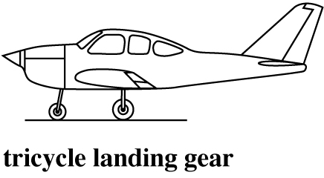

**Fig 3.4 Landing gear configuration**

## 3.4 Final Conceptual Design:

So after all the brainstorming, we concluded that our airplane must have following characteristics:

1. High wing twin boom configuration  
2. Single boom fuselage  
3. Boom tail  
4. Tri-cycle landing gears

# 4.0 Preliminary Design

After completion of conceptual design phase, preliminary design phase began to determine the sizes of different aircraft components according to different requirements. Detail analysis of Design is as follow:

## 4.1 Wing Design:

Some characteristics of wings are:

* Mh114 Airfoil is used due its high lift to drag ratio and lift at zero angle of Attack.
* MH-114’s camber also helps to produce negative moment needed for aircraft’s stability.
* Chord length is 10 inches.
* Wing span is 50 inches.

**Fuselage:**

In Pusher mechanism, Size of Fuselage plays a key role in thrust and hence flight of a plane. So, for optimum results, we came across on following:

1. Small and streamline fuselage has been designed so that propeller can give enough thrust.
2. Following mission requirements, 300g payload is taken as a concentrated load so that it does not affect stability as well as to keep fuselage as small as possible.
3. Enough hollow spaces were introduced in the fuselage to make it lighter but not compromising on structural integrity.

**Propulsion:**

1. Single propeller based plane is designed to make it less complex as well as light in weight.
2. Propeller was introduced just behind the fuselage.
3. 3S motor is used for as it gives 1800g of thrust that will be enough for our mission

**Tail:**

1. Double tail is used with two booms connecting it with fuselage.
2. Airfoil is used as Horizontal Stabilizers to produce negative moments to cater for stability required.
3. Usage of two Vertical Stabilizers helps giving plane more controllability.
4. Rudders and Elevators are deployed on tails to handle yaw and pitch of airplane respectively.

## 4.2 Design Trade Study

Initial Design and size approximation first starts with aim of making a stable plane.

## 4.2.1 Stability

For this whole plane C.G(Centre of Gravity) and C.P(Centre of Pressure) of wing must be aligned and should be as close as possible to achieve more stability.

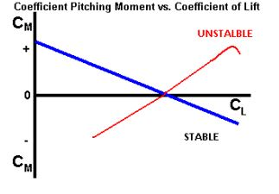

**Fig 4.1 Aircraft Stability pattern**

## 4.2.2 Static Stability

Ability of plane to back to its normal position after maneuvering can be said as Static Stability.

Typical Motions involved during flight are:

1. Longitudinal (Symmetric) motion
2. Involves C.G movement in vertical plane
3. Lateral (Asymmetric) motion
4. Involves rolling/yawing/side slip

Stability during flight can only be achieve if all the moments ends at C.G. Hence position of Wing in plane is crucial for stability.

## 4.2.3 Lateral Stability

To give lateral stability, mostly Dihedral angle is given but it is no feasible in acrobatic performance. Plane with pusher mechanism and having thin fuselage will not give enough stability issues so no Dihedral angle is given.

## 4.3 Airfoil Selection:

Most important part of aerodynamics is airfoil selection. General classifications of airfoils are:

1. Symmetric
2. Semi-Symmetric
3. Flat bottom

For our case, following mission requirements, we want an airfoil which can give maximum lift with least drag. i.e. whose Cl to Cd ratio is maximum as well as Cl.

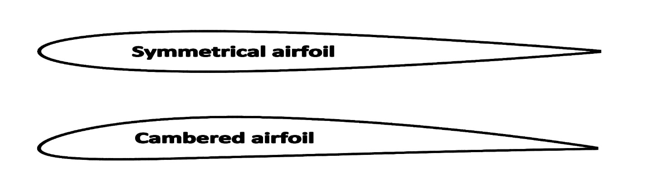

**Fig 4.2 Different Types of Airfoil (Image from Quora)**

After iterative analysis and research, we compare some very relative airfoil for this mission.

* NACA 5 Digit airfoil (138012)
* MH114

The 5-Digit NACA Semi Symmetrical is a compromise between Symmetrical and Flat bottom type. It combines both the lifting characteristics of Flat Bottom type as well as greater maneuverability of Symmetrical airfoil. It gives Higher maximum lift coefficient Low pitching moment.

But main problem is its main advantage is usage for high loads which is not required in our case as payload is just of 300g.

MH114 becomes most feasible airfoil for our mission as it has excellent lift to drag characteristics. It has in fact less Cl than some other airfoil but we are more interested in Cl to Cd. Also, MH114 is less cambered which makes it best candidate as taking vertical 360 loop is more feasible with MH114 than 5 digit NACA. Less cambered also makes it easier to manufacture than others.

Since aircraft to be designed must lift payloads as well as perform complex maneuvers, an airfoil was needed that could generate lift at low angle of attacks as well as generate negative moment for stability during flight.

Selection is done on its high Cl to Cd value i.e. it generates enough lift with minimum drag. Mission requirements for mission 3 also made MH114 feasible as we need least drag with maximum lift in that case

MH114 gives lift at Zero angle of attack as well as at negative angles that makes performing 360-degree loop possible hence making it most feasible airfoil.

We also choose MH-114 because for mission 3 our plane must draw minimum power from battery to remain in flight for maximum time. For this the plane must glide in the air. There is a term named Glide ratio, plane having higher glide ratio will glide maximum

Also from Previous experiments performed it is being observed that the glide ratio is directly proportional to the Lift to drag ratio.

***Mathematical Form:***



As our airfoil had the max Lift/Drag value so correspondingly the Glide ratio is also grater. So, for successful attempt for mission 3 it was best decision to use MH-114 airfoil.

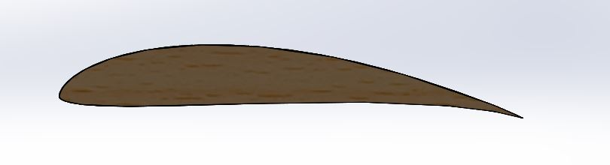***Fig 4.3 Mh114 Airfoil***

## 4.3.1 Lift Drag Analysis of Mh114:

Different traits of airfoil has been graphed and from this information, it becomes evident that it is best choice for given mission requirements.

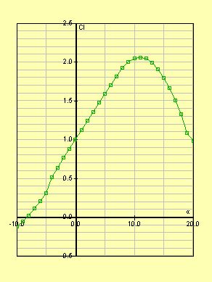

***Fig 4.4 Cl vs Angle of Attack Plot for MH114 ( Graph produced using Java foil Software)***



***Fig 4.5 Streamline flow across MH114 at Zero Angle of Attack (Graph produced using Java foil Software)***



**Fig 4.6 Streamline flow across MH114 at 10-degree Angle of Attack (Graph produced using Java foil Software)**

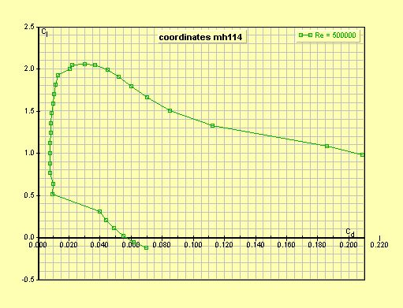

**Fig 4.7 Cl vs Cd Curve for MH114 airfoil (Graph produced using Java foil Software)**

Analysis on 3-D Wing

After the selection of airfoil, Analysis is carried out in 3-D Wing on SoildWorks Simulations. Remold Number is taken as 50000 and Pressure Distribution pattern can be observed on wing. It is evident that most pressure will be beard by front of wing while least pressure zone is formed at top of wing at specific area.

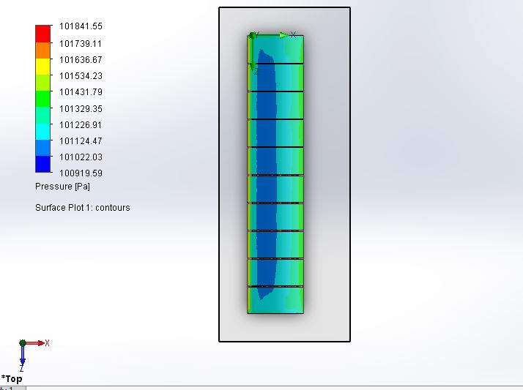

***Fig 4.8 Pressure Distribution on Wing (Top View) ( Produced using SolidWorks Simulations)***

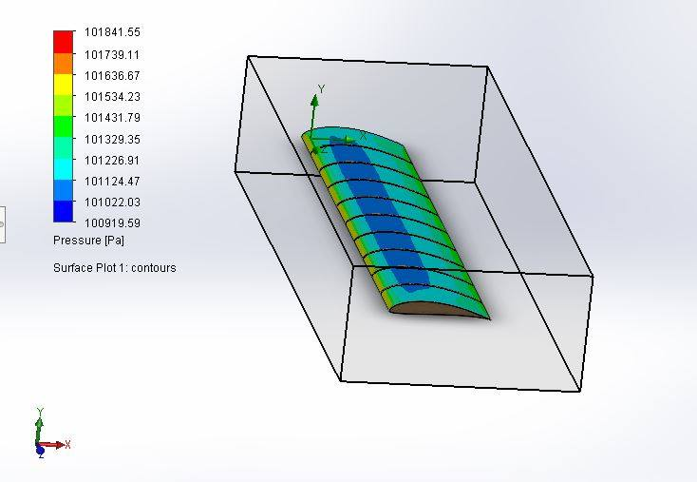***Fig 4.9 Pressure Distribution on Wing (Produced using SoildWorks Simulation***

# 5.0 Detail Design

Detail design consists of theoretical sizing from conceptual and preliminary design to convert the concept in reality. After a lot iteration and analysis, we now came across to work on our final design and dimensions.

## 5.1 Overall Dimensions of plane

|  |  |  |
| --- | --- | --- |
| **Dimensional Specifications** | |  |
| **Wing** | Airfoil | MH 114 |
| Span | 50.00 inches |
| Chord | 10 inches |
| Area | 500 inches2 |
| Aspect Ratio | 5:1 |
| **Fuselage** | Length | 22 inches |
| Width | 3.4 inches |
| Height | 8.2 inches |

**Table 5.1 Dimensions of Plane**

## 5.2 Tail:

Tail plays an important role in stability of plane. As using pusher mechanism and also having twin boom, tail has two vertical and two horizontal stabilizers. These helps having more controllability. Rudders extend throughout the width of the vertical tail While Elevators extend throughout horizontal tail. Tail is also made with Balsa Wood as manufacturing small parts is not easy for using other materials.

## 5.3 Controls and Servo Mechanism:

|  |  |  |
| --- | --- | --- |
| **Electronic System** | | |
| **Electrical System** | **Speed Controller** | **60A ESC** |
| **Radio Transmitter** | **Flysky i6** |
| **Channels** | **6** |
|  | **Servos** | **3 X tower pro sg5010** |
| **Motor** | **Type** | **DC BRUSHLESS( Ripper 2368)** |
| **Weight** | **80g** |
| **Battery** | **Type** | **Lipo (Gense ace 3s 2200mAh)** |
| **Rated Voltage** | **12V** |
| **No of Cells** | **3** |

**Table 5.2 Electronic System**

## 5.3 Drawing Package

This section of the chapter contains a detailed CAD package that demonstrates the design of the aircraft. Drawings for the aircraft dimensioning, structural arrangements system layouts and payload accommodations for the aircraft can be seen in the figures.

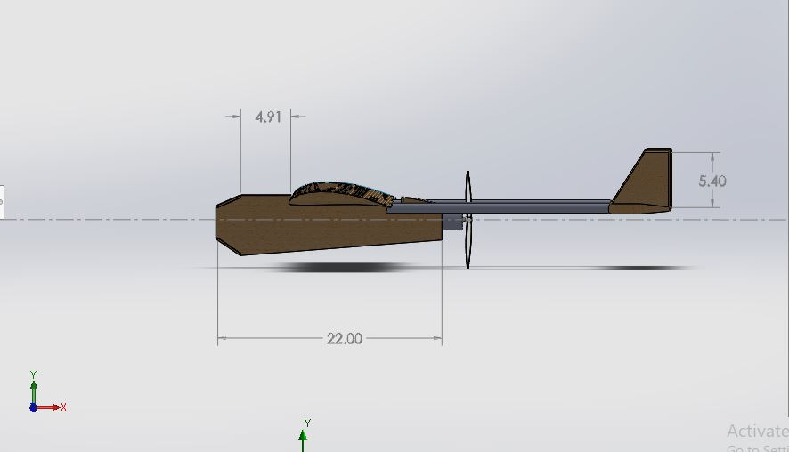

**Fig 5.1 Right side View**

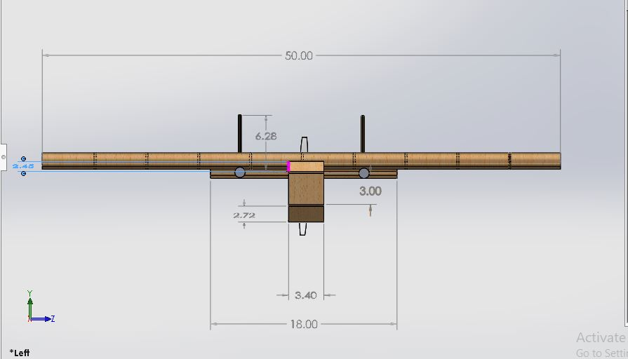

**Fig 5.2 Front View**

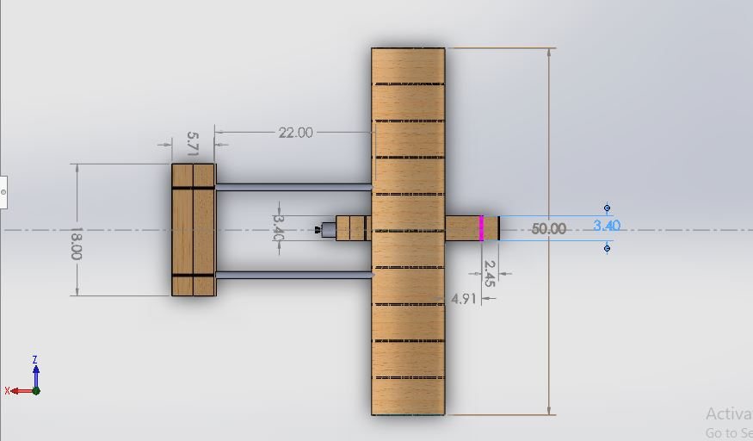

**Fig 5.3 Top view**

# 6.0 Manufacturing Plan and Process

## 6.1 Material Selection:

One of the most important part of Design is selection of right material for the plane. Considering the mission requirements, most important criteria for selection is Strength to weight ratio of the material. We focused on Balsa Wood and Carbon fiber.

## 6.1.1 Balsa Wood:

Balsa Wood is the most used material for RC plane because of its light weight, high strength and low cost. Despite Composite Material are now used mostly but still Many model planes, racing yachts are made from Balsa Wood. Balsa Wood is used for framing the frame of the plane This frame is then covered using fabric to made a light but strong structure.

**Balsa Wood Properties:**

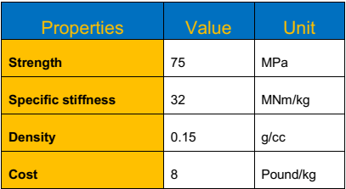

***Table 6.1 Properties of Balsa Wood***

## 6.1.2 Carbon Fiber:

Carbon Fibers use is increasing day by day being light weight and high strength to weight ratio. They can be molded into any shape.it has very small thermal expansion but it has some problems and important one is its high cost. Also high strength of Carbon fiber is in the direction in which threads are wrapped. Ability of absorbing forces decreases suddenly when direction changes, which can be catastrophic. To made a structure like this needs a lot of cost which can’t be handled in limited resources.

## 6.2 Final Selection:

Keeping in mind the given Mission requirements, Choice between several materials is made upon merit that will be best for our requirements.

## 6.2.1 Weight:

Keeping in view of Endurance limit, Weight is the most important factor and will be given Figure of Importance marks = 10

## 6.2.2 Manufacturing Ease:

A plane’s details should be given according to ease of manufacturing. Giving too much fine details may find difficulty in manufacturing, so it is given FOI = 7

## 6.2.3 Cost:

Keeping in mind of financial resources, it is also important to keep characteristics of plane in some limit, so it is given FOI = 8

## 6.2.4 Strength:

Capability of plane to bear stresses is very important property but as payload for this competition is little less, we may give it a little less FOI= 6

|  |  |
| --- | --- |
| Material Property | Figure of Importance |
| Weight | **10** |
| Cost | **8** |
| Strength | **6** |
| Ease of Manufacturing | **7** |

***Table 6.2 Figure of Importance***

Here we need material with most strength to weight ratio is required. Although Composites are considered as best choice but well-designed balsa structures are lighter than composites material for smaller plane as in our case. Balsa Wood is chosen for main structure as having required properties, most importantly it is easy to cut and shape.

Carefully considering the different mission requirements and our results in figure of Importance, Balsa is our Choice.

It is used to create the frame of plane. Solid foam is added to the core of the plane to make it lighter. It can be shaped easily using wire foam cutters.

## 6.3 Wing and Tail Design:

Wing is constructed in hollow method to minimize weight. Wing is not completely made by Balsa, infact gaps are given to make it hollow to make it as light as possible. Foam is used in core of wings to reinforce it as outer structure is made up of balsa to bear high stresses and foam to core to keep it light. Reinforcements rods are added to increase the strength.

Tail consists of Double Horizontal Stabilizers for better control. Rudders and Elevators are used and are made up of balsa wood also. Horizontal Stabilizers is made like airfoil to increase the horizontal stability. Elevators and Rudders are also added and all this configuration is made up of Balsa Wood.

## 6.4 Fuselage:

Slim Fuselage is made so that we can minimize drag as much as possible. It is made from Balsa Wood and then skinned to get desired shape. Its thickness is kept more at external surfaces and front section which are more vulnerable to stress concentrations and it will be less to rear section of fuselage. This helps to keep our weight less.

## 6.5 Propulsion:

Single Motor Pusher Propeller is used behind the fuselage. Main advantage is less weight and more stability. Diameter of propeller is taken as 10 inch while the distance between two booms is 11 inch giving tolerance of 0.5 inch between propeller and boom.

Motor for this will be 3s motor so that it will cater for less rated battery constrain.

## 6.7 Cost and Money:

After all processes, total cost comes to be Rs. 42700/-

|  |  |  |
| --- | --- | --- |
| Sr # | Item | Price( Rs) |
| 1 | Wood Balsa | 14000 |
| 2 | Motor and Propeller | 8000 |
| 3 | Battery | 4500 |
| 4 | Transmitter | 12000 |
| 5 | Servos | 3000 |
| 6 | Thermopoal Sheet | 1500 |
|  | Total | 42700 |

***Table 6.7 Cost and Money***

## 7.2 Surface analysis

For analyzing the aerodynamic characteristics of detail design of our aircraft, simulation on Solidworks was performed using the finite element meshing (FEA) approach. Von misses stress was created using aircraft design velocity

Several experiments were undertaken for different angle of attacks and inlet air velocity, but here only a single experiment results are discussed for the sake of understanding.

* Angle of attack = 0 degree.
* Inlet velocity = 80 ft/s
* pressure = 101.325 KPa
* Air properties at standard temperature & pressure S.T. P

CFD simulation on Solidworks was performed under the above-mentioned conditions and results were obtained to find the lift, drag.

* **DRAG FORCE = 18.63N**
* **LIFT FORCE = 140 N**

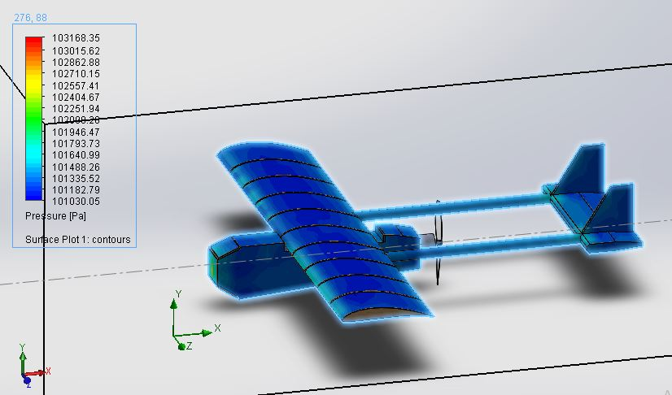

**Fig 7.1 Static Pressure Distribution**

Figure 7-1 shows static pressure distribution over entire aircraft body. From the results obtained it can be seen that maximum pressure distribution occurs at the leading edge.The analysis shows that our design will be having stable lifting straight flight characteristics.

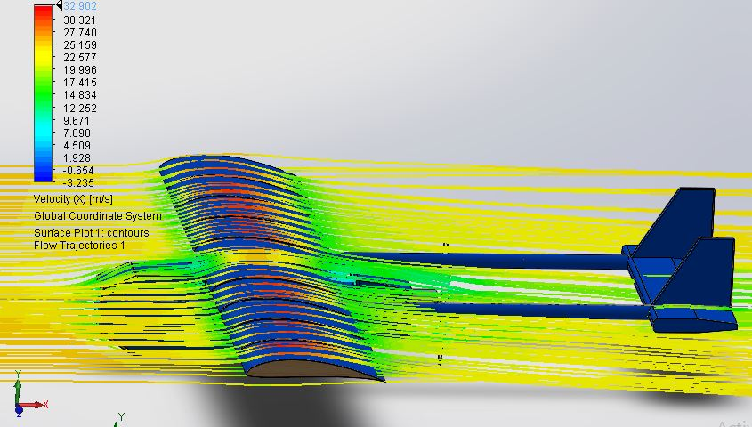

**Fig 7.2 Static Velocity Distribution on Plane**

Figure 7-2 shows static velocity distribution over entire aircraft body. From the results obtained it can be seen that at the leading edge, the velocity of incoming fluid is almost zero and it increases towards the trailing edge & at trailing edge its value is 17.415 m/s.

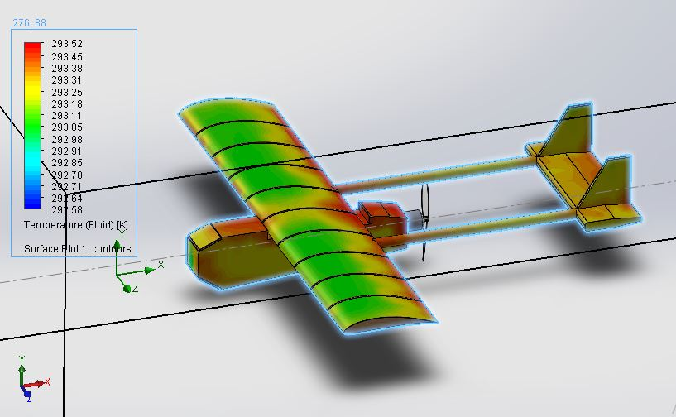**Fig 7.3 Temperature Distribution on Plane**

Figure 7-3 shows Temperature distribution over entire aircraft body. From the results obtained it can be seen that the temperature on overall body of aircraft is moderate because of lesser drag profile.

## 7.4 Safety Checks Prior to Test Flight:

* All parts of the control systems and propulsion were tested according to mission requirements and rules:
* Propeller and motor selected for our plane were tested for thrust stand and flight. DDM was used to collect data for voltage and current that allows the Propulsion to verify and calibrate aircraft’s tools
* Receiver battery was tested on the ground under different flight loads
* With adequate channels, we selected a receiver to provide a sufficient voltage to the servos, as well as the required programming.
* Aircraft control surfaces were tested prior to the first flight.
* To verify the internal resistance of different batteries we tested Ni-Cd & NiMH Batteries to verify that they had sufficient cooling and they performed as expected.

**References:**

1. <https://www.quora.com/How-is-lift-generated-with-symmetrical-wings>
2. <http://airfoiltools.com/airfoil/details?airfoil=mh114-il>
3. Anderson, John D., Fundamentals of Aerodynamics 5th Edition, McGraw-Hill
4. <https://en.wikipedia.org/wiki/Twin-boom_aircraft>
5. <https://www.mh-aerotools.de/airfoils/javafoil.htm>
6. <https://hobbyking.com/en_us/power-systems-1/electric-motors.html?___store=en_us>